Troubleshooting & Fixes (See other page for important tips)
Download software to operate the scanner from: http://www.scanace.com/

Connectivity issues
USB Cables, and USB ports can cause the common symptom listed below, if you are using a computer system with USB-C ports (USB 3.0) or USB-C mini ports: Some systems using USB-C to USB A Port converters, as well as regular standard USB-C( USB 3.0)ports can sometimes have issues properly scaling down the USB speeds needed to communicate effectively with the scanner, these symptoms can include

- Hangs on “Initializing scanner please wait….”  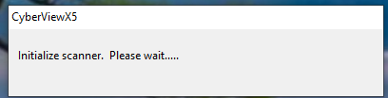 | - CyberView opens yet when Prescan or Scan is selected it hangs on “Calibrating film scanner please wait…”  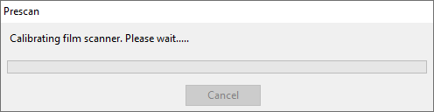  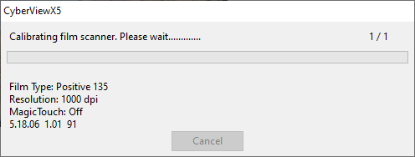
- The interface does open, yet when Prescan/Scan is selected the process begins then hangs on Scanning Strip and nothing further occurs, everything is frozen
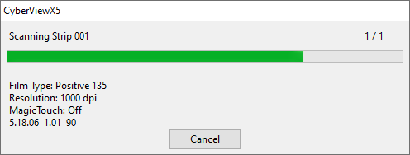

Fix
Try a different USB port on the computer, *Try a different USB cable for the scanner, Use a hub, hub devices can properly scale the USB speeds for the devices connected to it *Note: USB cables over 6ft are not supported neither are USB extension cables

Scan Error message or software freezes or quits unexpectedly
Open Image File Failed error or the scan process begins and freezes or closes at ½ or ¾ of the way through– This can occur when a security program is blocking access of the CyberView Scanning software (Examples: MS Windows Security, *BitDefender, AVAST, Malware fighter to name a few
*Bit Defender Security Software User’s if you experience this error - Open image file failed when attempting to scan an image
This can occur when your security application is blocking our software from writing an image file to
the selected directory. This type of situation occurs when the Active Virus Control module mistakenly detects some
applications as malicious. Active Virus Control is a Bitdefender module which constantly monitors the applications running on
your system and reports those with potentially malicious behavior. Since this feature is based on a heuristic system, there may be cases when legitimate applications are reported by Active Virus Control. When this situation occurs, you can exclude the respective application from being monitored by Active Virus Control. To add the program to the exclusions list, follow these steps:
EXAMPLE:
1. Open the Bitdefender or other brand of security software window.
2. Click the Settings button on the upper toolbar..
3. Click Antivirus on the left-side menu and then the Exclusions tab.
4. Click the Excluded Processes link. In the window that appears, you can manage the Active Virus Control process exclusions.
5. Add exclusions by following these steps:
a. Click the Add button, located at the top of the exclusions table.
b. Click Browse, find and select the application you want to be excluded and then click OK.
c. Keep the Allow option selected to prevent Active Virus Control from blocking the application.
d. Click Add.

*If these errors occur from using other 3rd party Security applications, steps above should be similar in how to allow our application giving it permission to write files to the hard drive folder you chose to save your scans into.

Important Tips for using scanner (See other page for important troubleshooting)

Tips for PowerSlide X
When setting up the scanner, make sure it is on a firm level surface, an out of level situation can cause slide feeding issues and jamming.
Slides not feeding in completely, first verify your slides are in good condition, not frayed or warped out of shape, next check they are suited for the included tray: Cardboard or plastic mounts 2.0-3.0 mm in thickness, if your slide mounts are very thin you might require a narrower slotted tray for 1.8-2.0 mm thick mounts which can be purchased here: https://www.bhphotovideo.com/c/product/396588-REG/Braun_15058_Compact_Slide_Tray.html
Despite user reviews mentioning a 100 slide carousel, these are no longer available; they were discontinued by the manufacturer (Braun) years ago. Should you desire additional slide trays they can be purchase here:
https://www.bhphotovideo.com/c/product/835152-REG/Pacific_Image_649899001639_Universal_Slide_Tray_For.html
For additional troubleshooting see: https://www.scanace.com/product/troubleshooting

Tips for PrimeFilm XAs
Certain B&W films can have different emulsions causing feeding issues, if you find the film frames of the B&W films are not aligning, then try scanning these specific films Emulsion down

For More FAQ & Troubleshooting
Please visit
http://www.scanace.com/

3740121A00

